SBIR Proposal
Redesign of an Intraosseous Needle
Michael Audette
Jonathan Hughes
Christopher Sullivan

April 22, 2006

Table of Contents
Specific Aims 3
Significance 4
Preliminary Work 7
Experimental Methods and Design 8
Creating a new intraosseous needle design 8
Prototype development 13
In Vitro Testing 14
Conclusion 17
Works Cited 17
Additional References 18

A. Specific Aims

Intraosseous needles are commonly used to deliver drugs and other medications to patients in situations where normal methods of intravenous drug delivery are not feasible.¹ This allows medications to be injected directly into the bone marrow, where they proceed to enter the venous blood circulation. Marrow can also be aspirated using an intraosseous needle for use in transplants, diagnosis, etc. One of the most common complications with manually inserted intraosseous needles is inadvertently penetrating both cortices of the bone during the insertion process. This plugs the end of the needle, rendering it useless for drug delivery. This requires reinsertion of the needle, causing additional patient trauma.
The goal of this project is to redesign the needle portion of manually inserted intraosseous device so that it retains normal infusion functionality, but also allows drug delivery to continue in event of distal end occlusion. This will facilitate drug delivery in cases where the needle overshoots, lodging in the far side of the bone’s cortex. When properly inserted, the needle will function similarly to current needle designs. Specifically, our aims are:
- Create a new needle design that allows for drug delivery or aspiration of bone marrow to continue even in cases of penetration of both cortices of the bone.
- We propose to modify the current designs by adding distal sideports on the end of the needle. These sideports will remain open and allow drug delivery even if the end of the needle is plugged and nonfunctional.
- Fabricate a prototype(s) for testing
  - From our final Solidworks model, a prototype needle will be created that will be compatible with current manual needle delivery systems (i.e. the injectors) using a CNC milling machine and 304 stainless steel.
  - We will fabricate two prototypes based upon the designs from Specific Aim 1 for in vitro testing.
- Test prototype(s) in vitro for functionality and effectiveness.
  - Our prototype(s) will be tested on sacrificed porcine to ensure that the redesign meets team requirements; namely that the redesigned needle performs as well as existing intraosseous needles under proper insertion conditions, but also can continue to operate when penetration of both cortices occurs. Additionally, in vitro testing will be employed to quantify the rate of fluid delivery under normal, unobstructed conditions versus delivery through the sideports in the event of occlusion.

B. Significance

The intraosseous (IO) route provides a proven, non-collapsible pathway for communication with the venous system.¹ When conventional venous access is unavailable, the IO space serves as a valuable alternate pathway into the bloodstream. Typically, IO infusions are used almost exclusively in preshospital, emergency settings. Contraindications to traditional IV access that may indicate IO access as the best pathway for infusion include hypovolemic shock and severe burns.
When a patient goes into hypovolemic shock, their veins collapse, making it very difficult, or even impossible to successfully establish an IV line to introduce fluid and drugs into the patient’s circulation.² For example, on the battlefield, it takes a medic 12 minutes (on average) to run an IV for a wounded combatant, and the success rate (i.e., patient receives necessary dosage to survive) is only 30%. Hemorrhaging caused by battle wounds naturally causes serious blood loss, so the time window to infuse blood and other necessary fluids is absolutely critical. Collapse of the veins increases the overall resistance of the circulatory system and effectively eliminates the pressure that fills the atria and ventricles of the heart during systole, typically resulting in ventricular fibrillation (VF). Under these conditions, the inside the bone serves as a huge non-collapsible vein which, remains stable during a state of hypovolemic shock unlike the rest of the vasculature. Intraosseous access provides immediate entrance into the venous system by penetrating the bone, and so blood and other fluids that need to be infused would be delivered much quicker. In addition to hypovolemic shock, other contraindications to conventional IV access may include cases involving cardiac arrest, arrhythmia, dehydration, drug overdose, stroke, myocardial infarction, dialysis, emphysema, respiratory arrest, hemophilia, severe trauma or burns, certain skin conditions, or end stage renal disease (ESRD).³
Another application of IO devices is bone marrow aspiration. Typically, this procedure is performed in a clinical setting, with a local anasthetic. Bone marrow samples may be used as a diagnostic tool by clinicians.
In the United States, the average yearly market for intravenous infusion processes exceeds 1.37 billion dollars, so as an alternative method of infusion or aspiration, there is clearly a large market for IO devices.
Currently, there are IO devices on the market that are applied manually (pushed into bone) and mechanically (battery operated drills).⁴ Our proposal is a redesign of a manual IO needle. Manual needles are used more often in children then adults, because the bones of children are typically softer and smaller. Current IO needles have a single a beveled hole at their tip. A trocar, a long slender metal rod, fits into the hollow space of the needle during insertion to provide support. After insertion this trocar is removed, leaving the path to the end of the needle free. A complication may occur when penetrating the bone during IO infusion. If the tip of the needle and its trocar get lodged into the other side of the bone (far cortex), the tip of the needle becomes occluded. This is a significant problem because the luminal cavity of the bone may be a small area, particularly in pediatric patients, requiring extreme precision. If there is blockage, then aspiration or infusion cannot take place. Our redesign will feature distal sideports, located along the shaft of the needle, to allow for flow through those ports in the event of a blockage at the tip. These sideports will be constrained in distance from the inserted end due to a desire to prevent the possibility of extravasation.
An initial search of the literature, conducted on PubMed, revealed that intraosseous infusion (IOI) is most often used in emergency, prehospital settings. Recent studies indicate a growing acceptance for IOI techniques in both children and adults. Studies have been conducted related to the ease of use of IO devices. For example, Miller et al conducted a feasibility study for the use of sternal intraosseous access by EMT students after a two-hour training session. The results of the study showed that out of 29 EMT students, 27 had successful IO needle deployments in 4 tries, while only 16 of the 29 were successful on their first attempt.⁵ Such studies imply that increasing the ease of use of IO devices is desirable.

C. Preliminary Work

We have fabricated a basic sketch and drawing of what our part will look like. We came up with a total of four possible models: Models A, B, C, and D. Based upon testing in Cosmosworks and Floworks, Model B was determined to be the best design and was prototyped.
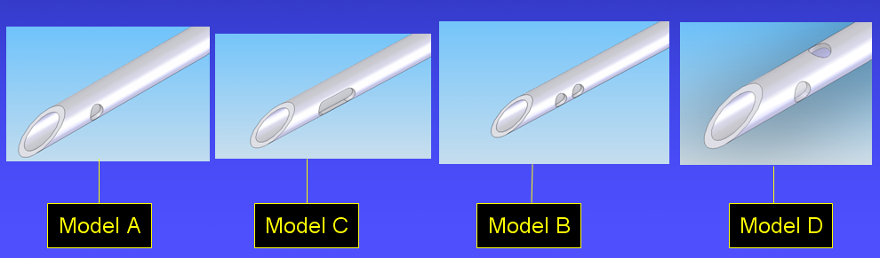
Figure 1: The four possible IO needle models.

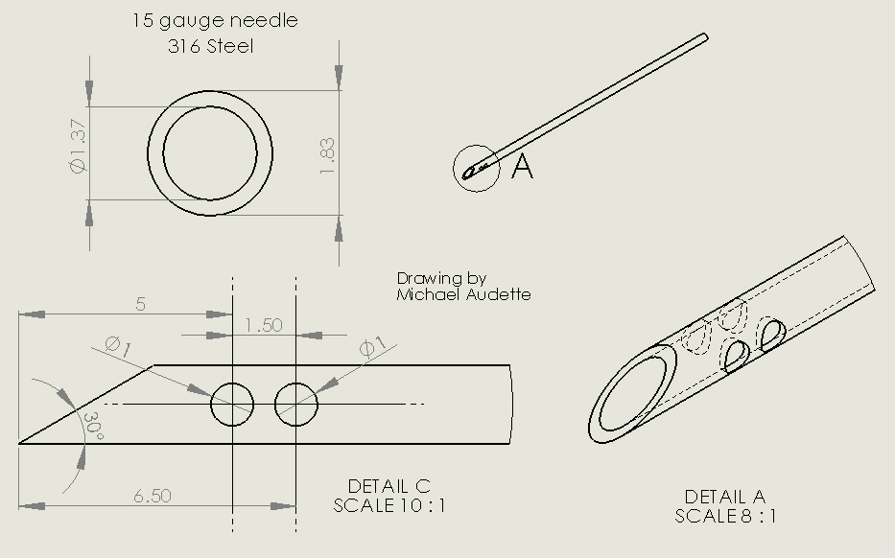
Figure 2: Detailed sketch of prototype Model B.

D. Experimental Methods and Design

1. Creating a new intraosseous needle design

In SolidWorks, our design was created to maintain compatibility with current injection devices, but with added functionality. Specifically, we added distal sideports near the distal end of needle. Factors that were examined in our Solidworks design included the placement, diameter, and number of sideports to add for maximum stability and functionality. The placement of the holes was important in order to ensure that the sideports will always remain in the lumen of the bone while drugs are being delivered. If the holes were placed too far proximally, then a needle that is not inserted far enough into the lumen may cause drug to be exasperated into the bone cortex itself, resulting in complications. The diameter of the ports was also important because adding ports will greatly change the flow dynamics through the needle, and we wanted to be sure that our design would not cause hemolysis or overly turbulent flow, both of which could damage blood products or marrow that may pass through the needle. The number of ports was kept to a minimum to ensure the most laminar flow pattern and also to ensure mechanically stability at the tip.
Our design was tested in COSMOSWorks to ensure that adding ports into the end of the needle would not structurally weaken it. The needle was tested to ensure that it would not deform or lose functionality while being inserted into the bone or while being handled. To simulate the act of pushing the needle through bone, a 100 lb force was applied along the long axis of the needle. The results of this test are shown in figure 3. It can be seen from this figure that the factor of safety around the area of sideports is greater than 10 (blue). At the tip, the FOS is around 1 (shown in red); however, some material loss is expected from the dulling of the needle as it pierces through the bone. Since the factor of safety around the sideports is so high, we feel that this shows that the needle will not fail by breaking off at the sideports when it is driven into the bone, and thus is mechanically stable.
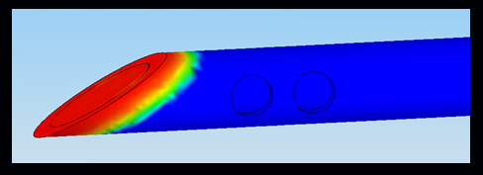
Figure 3: Cosmosworks Mechanical Stability Testing
The most critical part of our initial analysis was done using FloWorks. The sideports and ends of the needle were “capped” with boundary conditions set to correspond to the known parameters. At the sideports and distal tip, a static pressure of 25 mmHg, or the pressure inside the lumen of the bone, was used. At the proximal end of the needle, the boundary condition was set at a static pressure of 300mmHg, i.e. the pressure that would be maintained in a pressurized infusion bag during infusion. At the proximal tip, a velocity flow of 0.5 m/s, which corresponds to a volumetric flow rate of 88cc/min given the inner cross sectional area of the needle, was used to model the infusion of medications. The flow dynamics through each of our four models was modeled in order to compare the designs to each other.
Our goal in testing using FloWorks was to see if there were problem flow areas in our design that could be tweaked to yield better results. Specific factors that were looked at included backflow and velocity though the sideports. High backflow can lower overall infusion rates, while high velocities out of the sideports can lead to hemolysis. We also monitored the velocities and pressures inside and at the distal end of the needle to show that our needle delivered the same performance as other needles on the market. Each model was tested with the main delivery hole in the end open (i.e. normal infusion), and also with it “plugged,” to simulate the blockage that would occur if the tip where to go into the far bone cortex instead of remaining in the lumen. This tip occlusion was modeled as an ideal wall for testing purposes.
The first thing that we tested in FloWorks was how well our models performed under normal infusion. The results of one of these studies are shown in Figure 4. From the flow trajectories plot, in which 75 velocity flow trajectories were plotted, it is clear that the vast majority of the flow leaves through the tip. In fact, none of the 75 trajectories leave through the sideports. This means that there is essentially no flow through the sideports during normal infusion, and so we feel that this shows that under normal infusion our needle redesigns function in the same way as current IO needles.
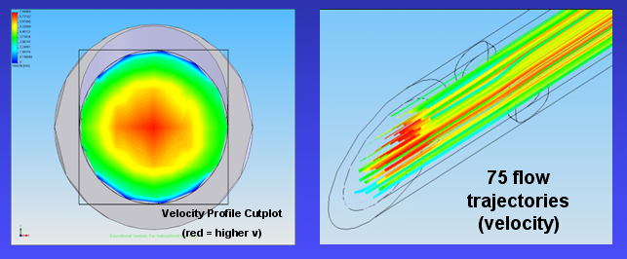

Figure 4: Normal Infusion Flow Trajectories and Velocity Cutplots

Our next phase of testing was done by simulating tip occlusion by modeling the distal tip of the needle as an ideal wall, and leaving the sideports as open to static pressure. This is equivalent to a situation in which the needle tip is driven into the far cortex (full occlusion), leaving the sideports open to pressure in the lumen of the bone. The same inlet velocity was used to model infusion through the needle.
The first model to be tested in this way was Model A. Model A showed very heavy backflow (15-20% of the overall flow), as is seen in the blue velocity traces in figure 5 at the tip of the needle. Backflow is undesirable because any flow that does not leave the sideports and instead flows into the occluded tip will alter the flow dynamics and lower the overall infusion rate. Model A also showed very high flow velocities out of the sideports, which could lead to hemolysis. When compared to the flow dynamics of Models B and D, Model A was clearly worse, and thus was eliminated as a possible model to prototype.


Figure 5: Model A Occluded Infusion Flow Trajectories and Velocity Cutplot

The next model was Model C, which had much lower backflow (less than 5%) than Model A, and similar flow profiles to Models B and D. As is in seen in the flow trajectories and velocity cutplots (figure 6), the flow velocity is very high before the sideport, and gradually moves slower as the flow leaves through the sideport. After the sideports, almost all of the flow has left, and so the flow velocities in this region are relatively small. This model was eliminated because of the high cost of producing the elongated sideport when compared to making simple circular sideports like in the other models.


Figure 6: Model C Occluded Infusion Flow Trajectories and Velocity Cutplots

The next two models, Models B and D, were very similar in flow dynamics. Both models showed very little backflow (2-3%) and nearly all of the flow left through sideports at the most distal part of the needle, as is seen in figures 7 and 8. Since these two models clearly had desirable flow dynamics, they were chosen to be prototyped. Model B was chosen to prototyped first, with Model D being prototyped once a satisfactory Model B prototyped was maintained. Unfortunately, due to time constraints, only Model B was able to be produced as a prototype.


Figure 7: Model D Occluded Infusion Flow Trajectories and Velocity Cutplots
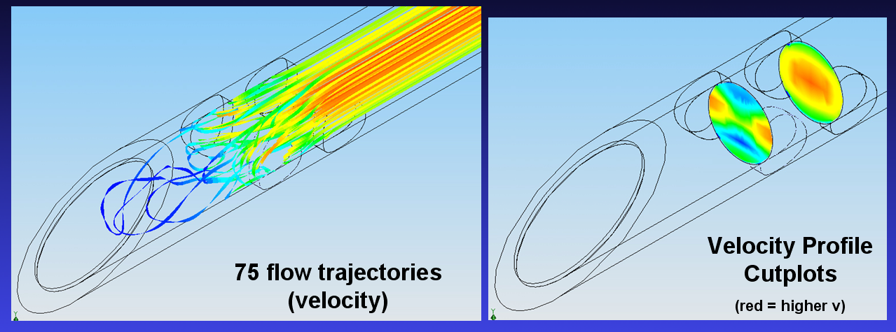
Figure 8: Model B Occluded Infusion Flow Trajectories and Velocity Cutplots

- Prototype development
Based on the fact that a manually inserted intraosseous needle is simple in structure and use (utilized though a manual mechanical force), our prototype was produced by a company, Vitaneedle, which specializes in the production of custom order needles. An E-drawing based upon our selected SolidWorks model (Model B) was used as the basis for the creation of the needle. Our prototype was created out of 316 stainless steel, which is the same material used in current IO needles. The distal sideports and 30 degree bias grind on the distal end were created using lasers. At the proximal end, a brass Luer Lock hub was attached to maintain compatibility with current IV tubing and syringes, which typically have Leur Lock attachments. Since it was not possible given the time frame of the project to plastic injection mold a new type of needle holder, our needle was created to be 15 gauge and 90mm to allow for compatibility with the current Jamshidi IO needle plastic holder and trocar. A total of two prototypes were created, to allow for the possible destruction of one during in vitro testing. A prototype of Model D could also be created at a later date, for the purposes of comparing it to Model B to see if one outperforms the other.

3. Test prototype(s) in vitro for functionality and effectiveness.
In vitro assessments were conducted in order to quantify prototype performance in physical tissue. A sample of porcine tibia was used to verify the devices ability to puncture bone and gain access into the intraosseous space. Literature suggests that porcine bone structure and composition serves as an adequate template for testing intraosseous needle use and that the results found from the testing is comparable to what would happen in a human.
An in-vitro test was run in which the elapsed time of infusion of 200 milliliters of 0.9% saline solution into a 500 mL graduated cylinder was recorded. The solution was subject to a steady inlet pressure of between 275 and 300 millimeters of mercury, which was maintained by pressure cuff around the IV bag containing the solution. The saline solution was dyed blue so that the observation of flow passing through the sideports could be enhanced, as shown in Figure 9.
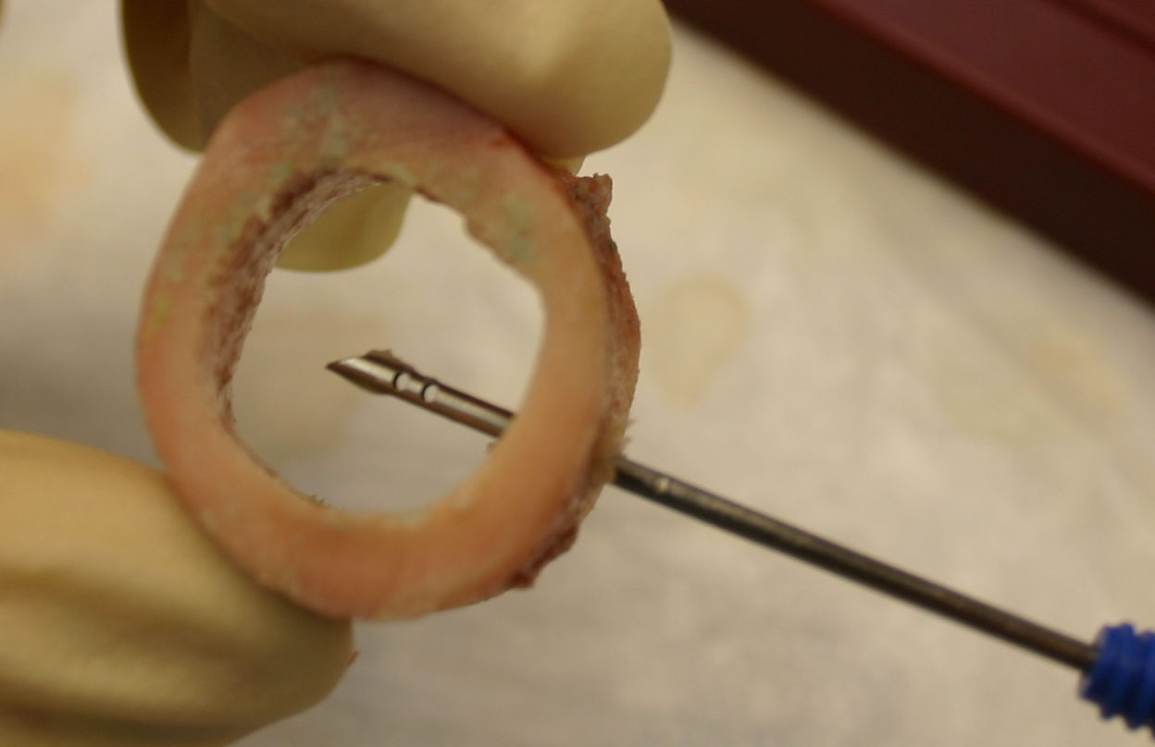
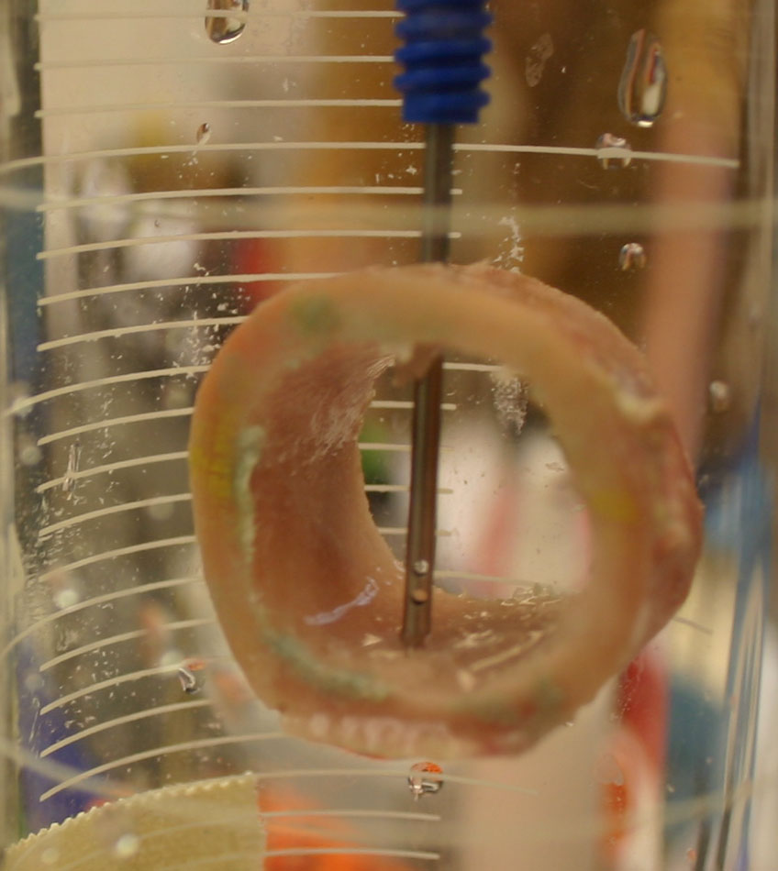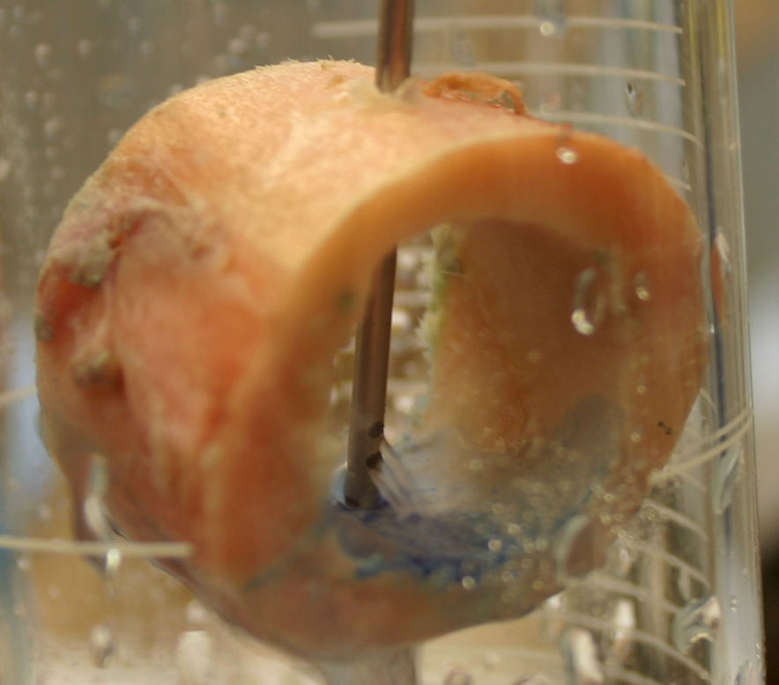

Figure 9. Various views of the prototype inserted into porcine tibia. The image on the right was taken during a trial.

Flow rate and infusion time were simulated for five different conditions, two using current Jamshidi intraosseous IO needles, and three with the prototype. Flow rate was calculated by dividing the known volume of 200 mL by the amount of time it took for total infusion of this volume for each trial. The five different scenarios that were considered were unoccluded and occluded infusion though the current Jamshidi IO needle, which does not have sideports. For the occlusion case, the distal tip of the Jamshidi needle was blocked. In case, it was not possible to deliver flow because the tip occlusion essentially clamped the end, and there was no path for fluid to exit the system. In this case the flow rate was zero. Infusion through the prototype was then considered under unoccluded conditions and two different occlusion conditions. For the first occlusion condition, the tip of the redesigned needle was plugged with a rubber stopcock. In the other condition, occlusion was represented by lodging the tip of the redesigned needle in the distal end of a chunk of porcine tibia. To model this, the prototype was driven into the lumen and forced to overshoot into the far cortex. Ten trials were conducted for each infusion scenario.
The results found from the testing for each condition are shown in Table 1 below:
Case | Mean Time (s) | S.D. for Time | Mean Flow Rate (cc/min) | S.D. for Flow Rate
Normal Jamshidi IO needle (no sideports, no occlusion) | 40.83 | 0.79 | 294 | 5.76
Normal Jamshidi IO needle with tip occlusion | - | - | 0 | -
Non-occluded IO needle with sideports | 40.34 | 1.74 | 298 | 12.82
IO needle with sideports; tip occluded by rubber stopcock | 40.80 | 0.77 | 294 | 5.61
IO needle with sideports; simulated occlusion in porcine tibia | 40.57 | 0.63 | 296 | 4.62

Table 1. Mean Time and Flow Rate of all five infusion cases with standard deviation shown. Ten trials were conducted for each condition.

Over ten trials, our prototype exhibited flow rates of close to 300 cc/min in both non-occluded and occlusion cases, which was very similar to the flow rate found in the unoccluded normal IO needle case. This satisfies our project goal of 200 cc/min more than adequately, and by having a flow rate so close to that of the unoccluded IO needle, the functionality of the needle is not lost even in occluded conditions. In all the cases we tested, the average infusion times for all the test cases were within one-half of a second of one another, obviously with the exception of the occlusion case that yielded no flow because there’s no passage for flow in the instance where the currently available IO needle is blocked. Additionally, in the case of the non-occluded needle with sideports, upon visual inspection, we noticed that virtually all flow passed through the open distal end of the needle even with the sideport openings present, meaning that there was negligible extravasation. Fluid was indeed drawn from the bone cortex in the event of tip blockage, showing that the sideports did indeed provide an alternate path for fluid flow.

E. Conclusion

After creating several models in Solidworks and testing them for functionality in Cosmosworks and Floworks, the best model was chosen and prototyped. The prototype testing showed that the specific goals of the redesigned intraosseous needle had been met, as the needle allows for the additional functionality of allowing for infusion through the sideports in the event of distal tip occlusion while at the same time allowing for infusion that is identical to current intraosseous needles in the case of normal insertion that does result in tip occlusion.

Works Cited:
- Frascone R, Dries D, Gisch T, et al: “Obtaining vascular access: Is there a place for the sternal IO?” Air Medical Journal. 20:20-22, 2001.

- Lavis M: “Pre-hospital adult intraosseous infusion.” Pre-hospital Immediate Care. 3:89-92, 1999.

- Hubble MW, Trigg DC: “Training prehospital personnel in saphenous vein
cutdown and adult intraosseous access techniques.” Prehospital Emergency Care. 5:181-189, 2001.

- Miller DD, Guimond G, et al. “Feasibility of sternal intraosseous access by emergency medical technician students.” Prehospital Emergency Care. 9:73-8, 2005

- Miller L, Kramer G et al “Rescue access made easy” Journal of Emergency Medical Services. VidaCare EZ-IO, 2005

Additional References:
- Boon JM, Gorry DL, Meiring JH:“Finding an ideal site for intraosseous infusion of the tibia: An anatomical study.” Clinical Anatomy. 16:15-18, 2003.

- Boyd, Russell J., Schultz, Jackie, Stuart, Peter. Comparison of two needle types for intraosseus access in an animal model. Department of Emergency Medicine, Lyell McEwin Health Services, Australia. Emergency Medicine. 2003 Aug. 15, (4):330-3

- Curran A, Sen A: “Best evidence topic report: Bone injection gun placement of intraosseous needle.” Emergency Medicine Journal. 22:366, 2005.

- DeBoer S, Seaver M, Morissette C: “Intraosseous infusion: Not just for kids anymore.” Emergency Medical Services. 34:56-63, 2005.

- Foex BA: “Discovery of the intraosseous route for fluid administration.” Journal of Accident and Emergency Medicine. 17:136-137, 2000.

- Frascone R, Kaye K, Dries D, et al: “Successful placement of an adult intraosseous line through burned skin.” Journal of Burn Care and Rehabilitation. 24:306-308, 2003.

- Greaves I, Evans GA, Boyle AA: “Intraosseous infusions in the adult.” Trauma. 1:291-299, 1999.

- Johnson DL, Findlay J, Macnab AJ, et al: “Cadaver testing to validate design criteria of an adult intraosseous infusion system.” Military Medicine. 170:251-257, 2005.

- Kruse JA, Vyskocil JJ, Haupt MT: “Intraosseous infusions: A flexible option for the adult or child with delayed, difficult, or impossible conventional vascular access.” Critical Care Medicine. 22:728-729, 1994.

- LaRocco BG, Wang HE: “Intraosseous infusion.” Prehospital Emergency Care. 7:280-285, 2003.

- Lavis M, Vaghela A, Tozer C: “Adult intraosseous infusion in accident and emergency departments in the UK.” Journal of Accident and Emergency Medicine. 17:29-32, 2000.

- Macnab A, Christenson J, Findlay J, et al: “A new system for sternal intraosseous infusion in adults.” Prehospital Emergency Care. 4:173-177, 2000.

- Orlowski JP: “Emergency alternatives to intravenous access: Intraosseous, intratracheal, and other-site drug administration.” Pediatric Clinics of North America. 41:1183-1199, 1994.

- Orlowski JP, Poermbka DT, Gallagher JM, et al: “Comparison study of intraosseous, central intravenous and peripheral intravenous infusions of emergency drugs.” American Journal of Diseases in Children. 144:112-117, 1990.

- Schafer DS, Gouzenne SR, Youmans-Rientiets C, et al: “Vascular access using the intraosseous route in the adult tibia.” Annals of Emergency Medicine. 21:638, 1992.

